**Master Excel**

**Manages multiple Excel files**

During the last year, I developed a utility, to help locating important Excel files.

The Main screen of the application looks like that:

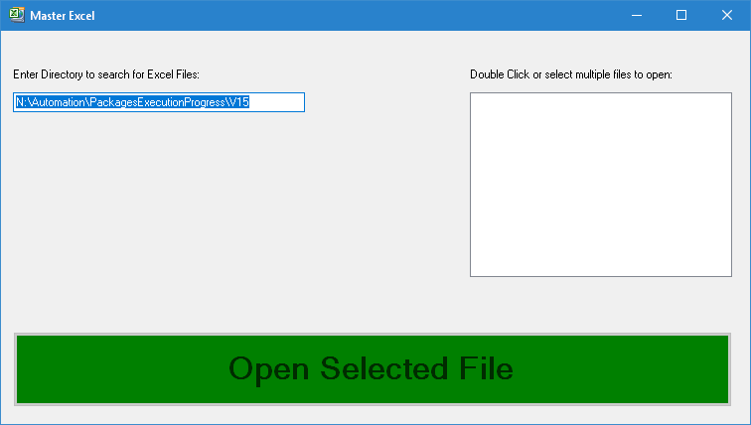

Now, we can:

* Change the directory, to a directory which contains Excel files->

The Excel files will be shown inside the files list: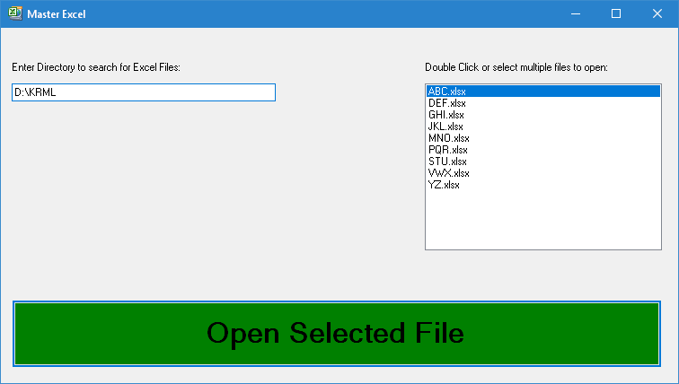

* Select a single file from the files list, then press "Open Selected File", or double-click on the selected file->

Excel application will be opened with the selected file.

* Selecting multiple files from the list, then press "Open Select File"->

Excel applications will be opened with the selected files:

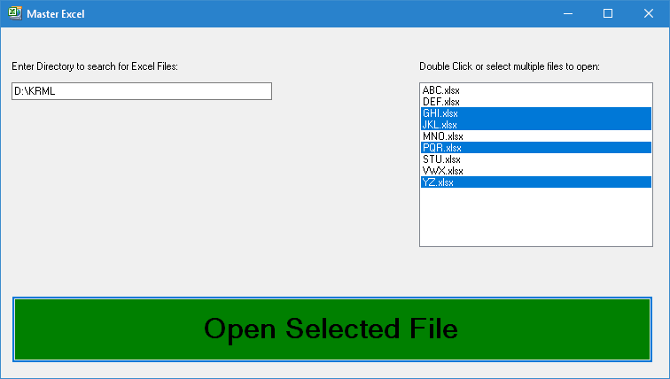

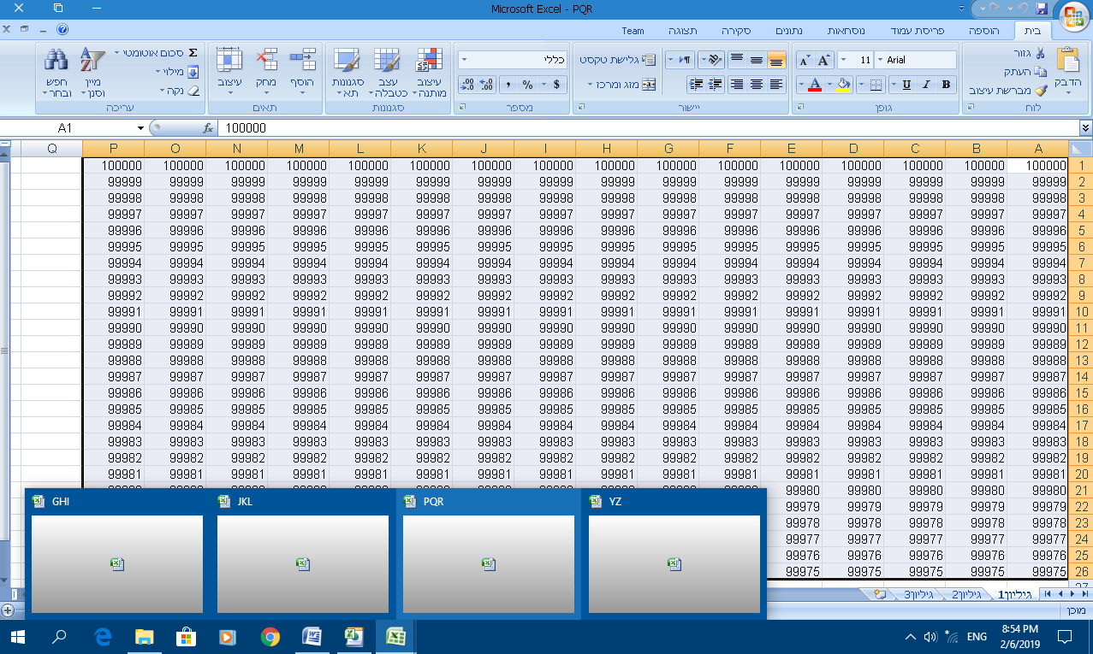

**Code location:**

<https://github.com/LiorBob/MasterExcel/blob/master/MasterExcel/frmMasterExcel.cs>